### CHEMISTRY TEST ONE

Name: ______________________________ Mark: /60

**Percentage: %**

**SECTION A: MULTIPLE CHOICE (15 marks)**

**Please answer on the multiple choice answer grid below.**

|  |  |  |  |
| --- | --- | --- | --- |
| Question | Answer | Question | Answer |
| 1 | A B C D | 11 | A B C D |
| 2 | A B C D | 12 | A B C D |
| 3 | A B C D | 13 | A B C D |
| 4 | A B C D | 14 | A B C D |
| 5 | A B C D | 15 | A B C D |
| 6 | A B C D |  |  |
| 7 | A B C D |  |  |
| 8 | A B C D |  |  |
| 9 | A B C D |  |  |
| 10 | A B C D |  |  |

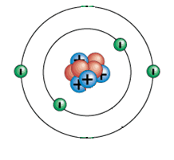**1.** The model on the right has an overall:

(a) Neutral charge.

(b) Positive charge.

(c) Negative charge.

(d) Nucleus charge.

**2.** The periodic table was first put together in 1869 by the chemist:

(a) Ernest Rutherford.

(b) John Newlands.

(c) Dmitri Mendeleev.

(d) Antoine Lavoisier.

**3.** Choose the correct definition for ‘atom’.

(a) The smallest part of an element that can take part in a chemical reaction.

(b) The smallest part of a cell.

(c) Anything that takes up space and has mass.

(d) The smallest part of an element that is unable to take part in a chemical reaction.

**4.** A substance made up of atoms with the same atomic number is known as:

(a) an element.

(b) an atom.

(c) a proton.

(d) a particle.

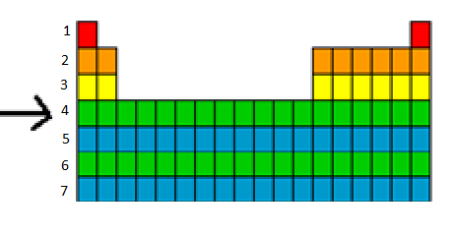**5.** The arrow is pointing to a:

(a) column.

(b) period.

(c) bar.

(d) group.

**6.** Gold is written as  on the periodic table. From this we know that:

(a) it contains 118 protons.

(b) it contains a total of 197 protons, neutrons and electrons.

(c) it contains 118 neutrons.

(d) it contains 197 electrons.

**7.** The noble gases are all:

(a) found on the right hand side of the periodic table and are highly reactive.

(b) found on the left hand side of the periodic table and are highly reactive.

(c) found on the right hand of the periodic table and are unreactive.

(d) found on the left hand of the periodic table and are unreactive.

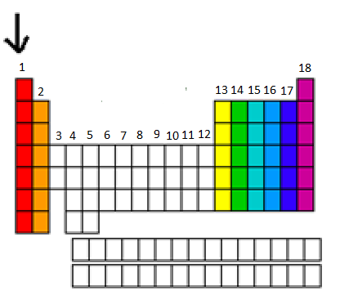**8.** The arrow is pointing to a:

(a) row.

(b) period.

(c) group.

(d) bar.

**9.** Which of the following are all transition metals?

(a) Li, Mn, Ca.

(b) Mn, Fe, Cu.

(c) F, Cl, Br.

(d) Na, K, Fe.

**10.** A particular atom has 8 protons, 8 electrons and 9 neutrons. Its atomic number is:

(a) 8.

(b) 9.

(c) 16.

(d) 17.

11. Metal atoms tend to ___________ electrons and become ________ ions. The missing words are:

(a) lose and positive.

(b) gain and positive.

(c) lose and negative.

(d) keep and negative

12. The periodic table was first set up based on:

(a) element’s atomic mass and properties.

(b) The theory of electronegativity.

(c) The theory of valence electrons.

(d) The theory of relativity

Use the diagram to answer question 13.

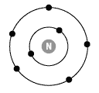

13. The element above has:

(a) 7 valence electrons.

(b) 2 valence electrons.

(c) 5 valence electrons.

(d) No valence electrons.

Use this table to complete question 14.

14. Which element in the table is most likely to lose electrons?

|  |  |
| --- | --- |
| Element | Electron configuration |
| A | 2, 7 |
| B | 2, 8 |
| C | 2, 4 |
| D | 2, 8, 1 |

15. All metals are:

(a) Malleable, conductors of electricity, solid at room temperature, ductile and located on the right hand side of the periodic table.

(b) Conductors of electricity, solid at room temperature, brittle and located on the right hand side of the periodic table.

(c) Malleable, conductors of electricity, solid at room temperature, ductile and located on the left hand side of the periodic table.

(d) Malleable, insulators of electricity, solid at room temperature, ductile and located on the right hand side of the periodic table.

**SECTION B: SHORT ANSWER (45 marks)**

1. Label this diagram below using the correct group names.

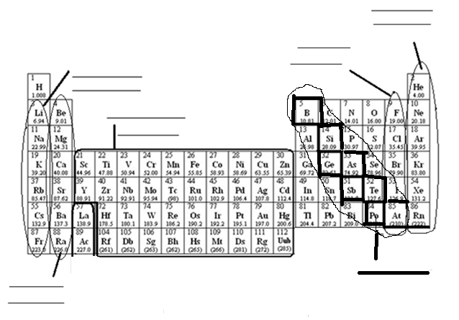

(6 marks)

**b.** Fill in the table below using the periodic table above.

|  |  |
| --- | --- |
| Element | Group of the periodic table |
| Lithium |  |
| Helium |  |
| Chlorine |  |
| Iron |  |

(4 marks)

1. Draw the electron configuration for the elements in the table below.

|  |  |
| --- | --- |
| Element | Electron configuration |
| Carbon |  |
| Lithium |  |
| Argon |  |

(3 marks)

**3.** Label the diagram of the atom below. (5 marks)



b. what element is this?

**________________________**

(1 mark)

**4.** Fill in the table below using the periodic table supplied. (20 marks)

**2 marks for all of row correct, 1 mark for most of the row correct.**

|  |  |  |  |  |  |  |
| --- | --- | --- | --- | --- | --- | --- |
| Element | Symbol | Atomic number | Mass number | Number of protons in each atom of the element | Number of neutrons in each atom of the element | Number of electrons in each atom of the element. |
| Silver |  |  |  |  |  |  |
| Helium |  |  |  |  |  |  |
| Magnesium |  |  |  |  |  |  |
| Sodium |  |  |  |  |  |  |
|  | Au |  |  |  |  |  |
|  | Fe |  |  |  |  |  |
|  | W |  |  |  |  |  |
| Hydrogen |  |  |  |  |  |  |
| Copper |  |  |  |  |  |  |
|  | Li |  |  |  |  |  |

**5.** An element has been found. It is solid at room temperature, reacts explosively in water, tends to lose one electron, when solid it is malleable and it can conduct electricity. Which group of the periodic table should it be put in?

**__________________________________________________________________________**

(1 mark)

Draw a graph using the information from the table below. (5 marks)

Don’t forget all the things that a graph needs!

|  |  |
| --- | --- |
| **Year** | **Number of elements known** |
| 1700 | 13 |
| 1750 | 15 |
| 1800 | 34 |
| 1850 | 59 |
| 1900 | 84 |
| 1950 | 98 |
| 2000 | 114 |

[](http://www.google.com.au/url?sa=i&rct=j&q=graph+paper&source=images&cd=&cad=rja&uact=8&docid=bnDyK-WDEHhooM&tbnid=OH_xw5ZTcFEuvM:&ved=0CAUQjRw&url=http://virtualmathtutor.blogspot.com/2010/11/how-to-draw-circle-without-compass.html&ei=RKw4U5fxF8fClQWCrIGoCQ&psig=AFQjCNHahbsWAgdANQM5RZCXw4z48cLLBw&ust=1396309252654415)

